**Diluting a Fluid Sample using Balanced Mix-Split Operations on a Digital Microfluidic Biochip**



**A PROJECT REPORT**

*Submitted by*

**Saptarsi Saha,Raisa Basak,Suchana Banerjee**

**With the University Roll Number at Maulana Abul Kalam**

**Azad University of Technology, West BENGAL as follows**

**12614001086, 12600113042 and 12600113105**

*Under the Supervision of*

**Prof. Nilina Bera**

**Assistant Professor**

**Department of Computer Science & Engineering**

*In partial fulfillment for the award of the degree*

*of*

**BACHELOR OF TECHNOLOGY**

**in**

**COMPUTER SCIENCE & ENGINEERING**

**HERITAGE INSTITUTE OF TECHNOLOGY**

**WEST BENGAL UNIVERSITY OF TECHNOLOGY**

**KOLKATA**

January, 2017



**HERITAGE INSTITUTE OF TECHNOLOGY, KOLKATA**

###### **WEST BENGAL UNIVERSITY OF TECHNOLOGY**

## BONAFIDE CERTIFICATE

Certified that this project report *“***Diluting a Fluid Sample using Balanced Mix-Split Operations on a Digital Microfluidic Biochip***”* is the bonafide work of “**Saptarsi Saha, Raisa Basak, Suchana Banerjee**” who carried out the thesis work under my supervision.

SIGNATURE SIGNATURE

**Prof. (Dr.) SubhashisMajumder Prof. NilinaBera**

**Head of the Department Project Guide, Asst. Prof.**

Department of Computer Science & Engineering

**Heritage Institute of Technology**

(A Unit of Kalyan Bharti Trust)

Chowbaga Road, Anandapur,

Post-East Kolkata Township, Kolkata- 700107

**EXTERNAL EXAMINER**

Acknowledgements

I would take this opportunity to thank Prof.(Dr.) Pranay Chaudhuri, Principal, Heritage Institute of Technology for providing me with all the necessary facilities. Following which, I must thank my Head of the Department, Prof. (Dr.) Subhashis Majumder, and our Departmental Coordinator, Prof. (Dr.) Poulami Das for showing confidence in my innovative idea.

We would also like to express my heartiest gratitude to my respected project mentor Prof. Nilina Bera for her constant guidance and support.

I convey my heartfelt thanks to my Faculty Members and Laboratory Assistants. Last but not the least; I thank all my friends for their cooperation and encouragement that they have bestowed on me.

**Signatures**

SAPTARSI SAHA

RAISA BASAK

SUCHANA BANERJEE

**TABLE OF CONTENTS**

1. **Abstract**
2. **Introduction**
3. **Working.**
4. **Dilution Algorithms.**
5. **Dilution and Mixing with Reduced Wastage (DMRW).**
6. **Improved Dilution and Mixing algorithm(IDMA)**
7. **Percentage Error introduction in DMRW and IDMA Algorithm.**
8. **Future scope of IDMA algorithm, waste reduction and re-utilisation.**
9. **Conclusion.**

ABSTRACT

The development of Lab-on-a-chip technology intends to replace macro labs on which we depend for synthesis and chemical analysis by a small portable chip.The main challenge to development of lab-on-a-chip devices is the design and fabrication of devices on a very small scale which is functional.Combination of advance technology with nanotechnology,microbiology and physics has led to the the creation of Lab-on-a- Chip.

Lab-on-a-chip aims to be compact, cost effective, less error with zero human intervension and high parallelization.Digital microfluidic (DMF)-based biochip is one such lab-on-a-chip in which nanoliter-volume fluid droplets are manipulated on a 2-D electrode array.

To implement the algorithm, an architectural layout of a DMF-based Lab-on-a-chip consisting of two O(n)-size rotary mixers and O(n) storage electrodes is designed . The droplet is placed between the two plates and rests on a hydrophobic surface over an electrode. The aim is to finish the process on DMF in finite n number of steps with the time complexity O(n) for any given concentration factor with minimal waste droplets. The project also aims to reuse the waste at each step if possible and also to check if the desired solution is achievable or atleast to the nearest value. In this project efforts have been put up to successfully implement DMRW algorithm and IDMA algorithm.

INTRODUCTION

With the rising population all over the world , the burden of diseases is also increasing rapidly. Cardio arrest, HIV,Cancer , Blood pressure are common names in each and every household. In such a situation , the need of the hour is quick effective health care where citizens can access health services without incurring financial hardship and delay . The medical world is constantly evolving to make new medical advancements and provide universal health care rapidly. This medical evolution combining with nanotechnology,microbiology and physics has led to the the creation of Lab-on-a- Chip.

Lab-on-a-chip is the latest technology which enables operations which else requires laboratory, sythesis of complex compounds and analysis of chemicals , on a small-scale level ,on a hand-held postable device. Lab-on - a- chip not only strikes out the requirement of a huge laboratory but also reduce the time taken to synthesize and analyse a product. It helps in performing studies of physical, chemical, and biological processes.

Micro-electronics,Biochemistry, computer-aided design and optimization, fabrication technology are already available in the market but Lab-on-a-chip offer more advantages like minimal human intervention , more accurate results and precition.Lab-on-a chip is not only highly sensitive but also has low sample and reagent consumption. Also,Lab-on-chip can operate on site and provide high-throughput screening . It cut downs the idea of transporting the samples to a laboratory for synthesis and chemical analysis.Further it provides better results as operation on a small scale mean that it is easier to control the movement and interaction of samples, making reactions much more efficient.

Lab-on-a-chip is the combination of advance nanofluidics and microfluidics with advance technology. Microfluidics is the study of low volume fluids, usually in the range of microliters (10-6) to picoliters (10-12),where the low volume liquid is controlled and processed to achieve multiplexing, automation, and high-throughput screening.Modern techniques like High-performance liquid chromatography (HPLC) and Capillary electrophoresis (CE) are used to obtain extremely accurate results from a small sample size. Developments in the field of nanotechnology has contributed significantly in developing lab-on-a-chip. For exmple , lithography has contributed to create small, micro-scale pumps for manipulating flow from polydimethylsiloxane (PDMS) which is a silicon-based organic polymer . Nanosensors are also extremely useful in allowing a high degree of analytical flexibility in a lab-on-a-chip without increasing the size of the chip any further.

Lab-on-a-chip is one of the most promising technologies for future high throughput diagnostics. It will not only provide real time process control and monitoring increase sensitivity in a compact way but will also integrate thousands of biochemical operations that could be done by splitting a single drop of blood collected from the patient onto a single chip.

WORKING

Continued growth in this emerging field of lab-on-a-chip depends on advances in design automation. Lab-on-a-chip integrates a number of lengthy operations, such as detection, sample pretreatment,and sample preparation on one chip.This means the pre-processing steps should be automated on the chip itself. Designing and fabricating the dilution is extremely challenging on a n digital microfluidic (DMF) biochips as it may require any value of concentration of the reagents. Due limited availability of stock solutions for samples and costly reagents,Lab-on-a-chip aims to minimize the waste droplets produced during the process.

Dilution is used in many chemical processes to obtain a concentration by mixing stcok solution with its diluent. Generally, there are two types of dilution methods: serial and linear dilution.In a DMF-based biochips,biochemical samples can only be mixed using discrete volumes of liquid droplets hence resulting in serial dilution which leads to non linear concentration level.Therefore achieving a desired concentration of the stock solution within a minimum number steps is a challenge.

Here the problem of automatic dilution of a sample or mixing of two biochemical reagents using DMF biochips is presented. The aim is to finish the process in finite n number of steps with the time complexity O(n) for any given concentration factor (CF), with an error less than 1/ (2^n) .

A set up consisting of electrodes with two DMF rotary mixers is put up. This technology helps in automation method. A unit cell in the array includes a pair of electrodes that acts as two parallel plates. The bottom plate contains a patterned array of individually controlled electrodes, and the top plate is coated with a continuous ground electrode. The droplet is sandwiched between the two plates and rests on a hydrophobic surface over an electrode. The droplet is moved by applying a control voltage (above a threshold voltage) to an electrode adjacent to the droplet and, at the same time, deactivating the electrode just under the droplet. This electronic method of wettability control creates interfacial tension gradients that move the droplets to the charged electrode. By varying the patterns of control voltage activation, many fluid-handling operations, such as merging, splitting, mixing, and dispensing of droplets, can be executed.

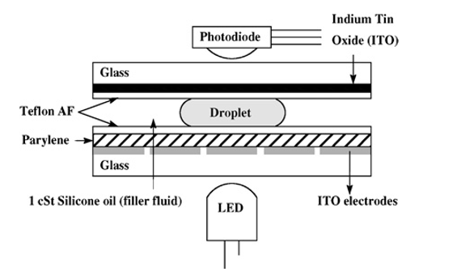

Dilution and Mixing with Reduced Wastage (DMRW)

In this program what we have done is, we have taken two solutions one is that of a Sample (say KCL) and the other is a Buffer. The solution are in in equal proportion i.e. 1:1 by vol.

The process starts with the two initial CFs (one is the sample and other is buffer). At every mix/split step, the algorithm requires only two CFs, called the boundary CFs, one lower and one higher than the target Ct such that the interval between the boundaries, CFs is minimum.

After mixing the two boundary samples at any instant of time, it checks whether the resulting CF is less or greater than Ct.

In former case the current sample is mixed with the sample having the smallest CF greater than it and in the latter case, it is mixed with the largest CF sample smaller than it. In this process, the resulting CF approaches further toward Ct and the process is repeated systematically.

In the ﬁrst case, the lower boundary of CF is changed to the current CF keeping the higher boundary CF same as the previous one.

In the second case, where the current concentration is greater than Ct, the higher boundary CF is changes to the current CF keeping the lower boundary CF same as the previous one. This mix/split process continues until the target concentration Ct reaches.

Basically what we are doing is we are first taking input from users for the number of steps , after the value of the denominator and with this we are displaying the initial values of Buffer and Sample. For eg. Id the number of steps is 10 then denominator is 2^10=1024. So the buffer will be 0/1024 and Sample will be 1024/1024. After that we are starting the mix/spilt process . Before that we are also taking a input for the target value(Ct) which the user want to reach with the given number of steps. Then we are calculating the CF one by one unless we find the target CF which is input by the user. Lastly when the target is reached we are displaying the message that the Required target is reached.

DMRW WITH VOLUME ERROR

This semester we started working on DMRW Algorithm along with error. Since no system is ideal in the real world therefore even the bit scanning algorithm might work well in ideal case scenario but in the real world it might not be able to provide the optimal result due to some error which might occur due to the erroneous machine, or several other reasons .Therefore we took into consideration this fact and tested our program by introducing error at a particular step and see if the end result is somewhere near to the target CF(Concentration Factor).

In this experiment what we did is we added error at a particular step in our algorithm.in ideal case when we reacted the solution(say 1 vol) with the buffer(say 1 vol) we generated a CF(Concentration Factor) of two volume . Out of these two vol of CF’s we used just 1vol to react with the solution or Buffer accordingly in the further steps. Thereby leaving behind a waste droplet of 1 vol. Say supposingly due to some reason the Bio-chip is not able to split the droplet into exact two halves. And it might happen that the droplets separated into two halves might not be of equal length and contain some some error say ‘e’. And thus the droplets generated be ‘X+e’ and ‘X-e’.

Therefore we continued our experiment by adding percentage error at a particular step and comparing that with the ideal CF (without error ). We added different percentage of errors at different steps to draw some conclusion.

**Output with error of DMRW Algorithms.**

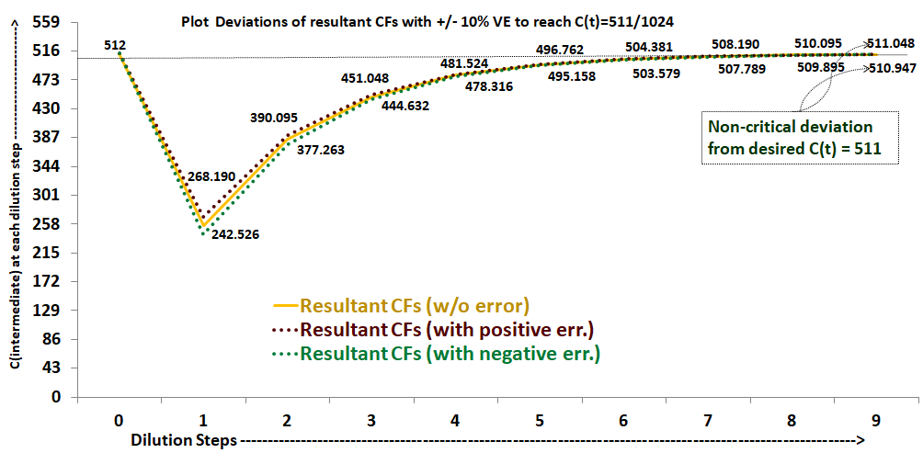

Deviation plot of C(t)=511 on application of 10% error.

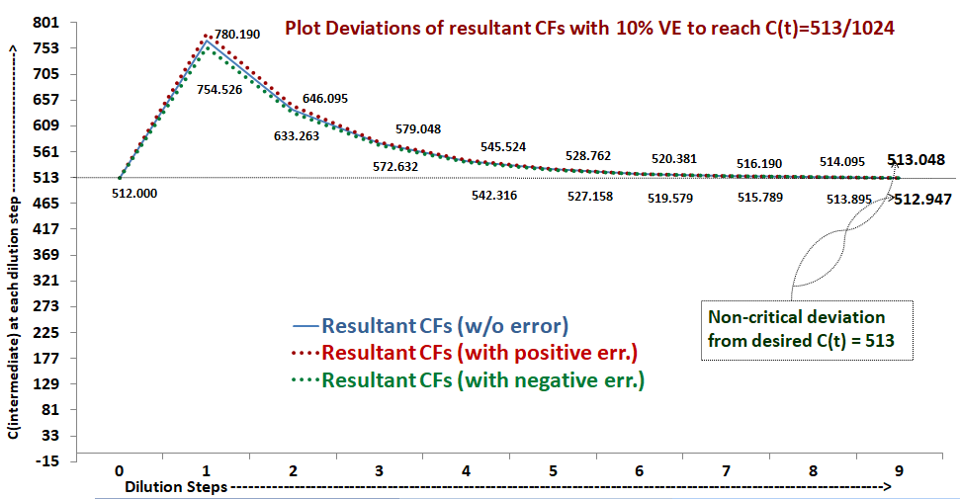

Deviation plot of C(t)=513 on application of 10% error.

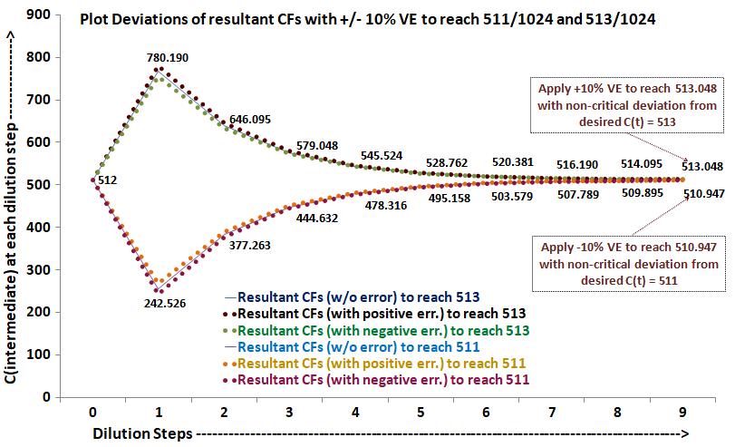

Complementary Deviation plot of C(t)=511 & C(t)=513 on application of 10% error.

**Output with error of IDMA Algorithms.**

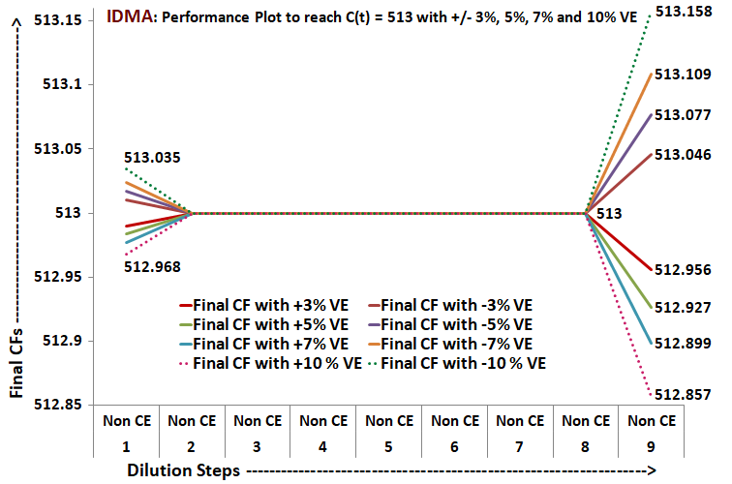

Performance plot of C(t)=513 with application of 3%,5%,7%,10% error.

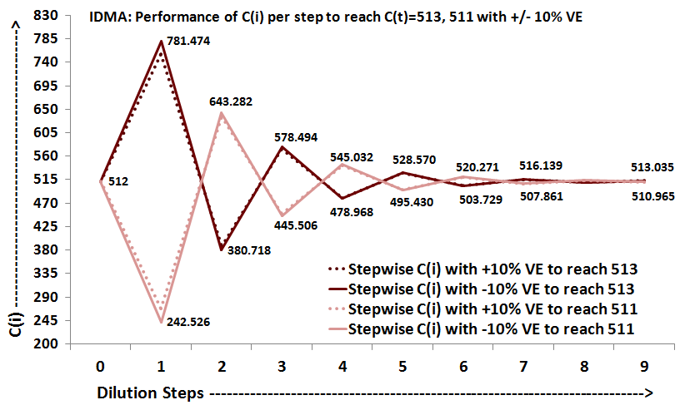

Stepwise Performance Plot of IDMA with C(t)=513 and C(t)=511 with 10% error.

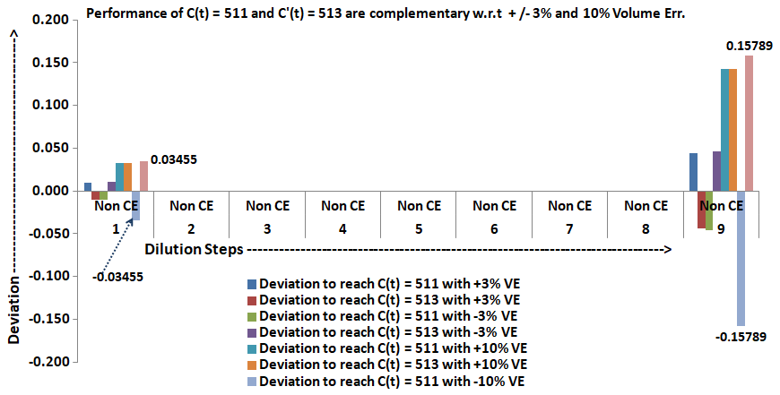

Complementary Performance Plot of 511-513 with 3% and 10% volume error.

CONCLUSION

The conclusion that we drew from our experiment is if we introduce +ve error say 5% for 2^5 bit at the first step and we compare that with the CF generated in ideal case we see that the Deviation is below 0.5 and is NON CRITICAL. Therefore weather the error is +ve or -ve in the first step it makes no considerable difference in our result and we do not have to worry about +ve or –ve polarized LOC

We also inserted different percentage of errors different steps in order to find out a particular pattern in the generation of output so at to make it feasible to implement that in our biochip.

The Bit scanning algorithm has lot of scope and we are able to reuse the waste droplets than we can even increase the efficiency of the system and get near to accurate results at lower cost and lower percentage of errors but since the program is for n bits hence adding the waste droplets and also the errors in the program is making it difficult to handle the data . But we are optimistic that in the future we might be able to make an efficient program which could take into consideration both the errors as well as reusability of waste and give an optimal result at a lower cost of buffer and solution.